ELECTRIC CURRENT TUTORIAL
SOLUTIONS

1. D
2. A
3. B (parallel circuit)
4. D
5. A
6. B
7. B
8. A
9. A
10. A
11. B
12. C

13. The resistance causes a decrease in the flow of charge and a drop in electrical potential.

14. A voltmeter measures potential difference from one point to another point.

15. The electrical conductivity of snow is very low.

16. The current returns to the negative side of the battery by travelling through the metal body of the car.

17. ammeter.

18. resistance.

19. series.

20. series.

21. parallel.

22. parallel.

23. parallel.

24. (a) R_{T} = 10.0 + 20.0
= 30.0 Ω

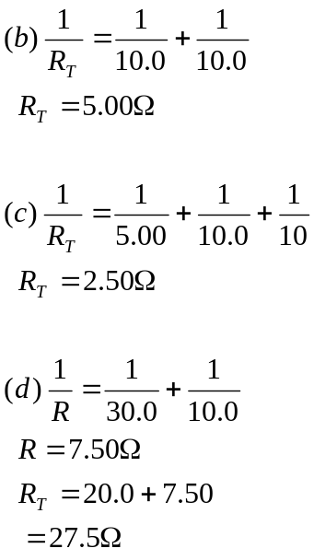

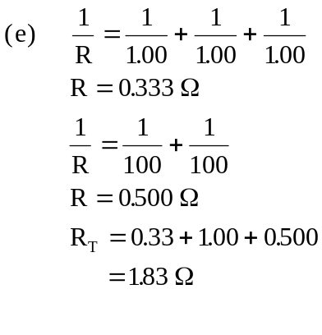
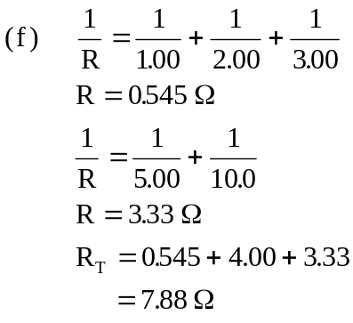

25. V = IR
240 = 0.250 × R
R = 960 Ω

26. V = IR
6.00 = 0.100 × R
R = 60.0 Ω

27. (a) R_{T} = 20.0 + 30.0
= 50.0 Ω
(b) V = IR
10.0 = I × 50.0
I = 0.200 A
(c) V_{20Ω} = IR
= 0.200 × 20.0 = 4.00 V
V_{30Ω} = IR
= 0.200 × 30.0 = 6.00 V

28. V = IR
12.0 = 0.0500 × R_{T}
R_{T} = 240 Ω
R_{unknown} = 140 Ω

29. (a) 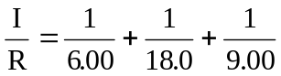

R_{T} = 3.00 Ω

(b) V = IR
12.0 = I × 3.00
I = 4.00 A

(c)
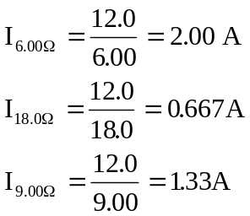

30. (a) V = IR
240 = 8.00 R_{T}
R_{T} = 30.0 Ω

(b)
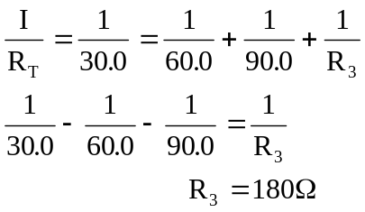

31. 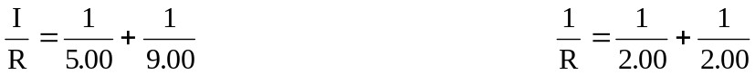

R = 3.214 Ω R = 1.00 Ω
R_{T} = 2.00 + 3.214 R_{T} = 1.00 + 5.00
= 5.214 Ω = 6.00 Ω
I_{2Ω} = 1.15 A I_{5Ω} = 2.00 A
V_{2Ω} = 1.151 × 2.00 = 2.30 V V_{5Ω} = 2.00 × 5.00 = 10.0 V
Vparallel = 6.00 – 2.30 = 3.70 V Vparallel = 12.0 – 10.0 = 2.00 V
I_{3Ω} = I_{2Ω} = 0.740 A V_{2Ω} = 1.00 x 2.00 = 2.00 V
V_{3Ω} = 0.740 × 3.00 = 2.22 V
V_{2Ω} = 0.740 × 2.00 = 1.48 V
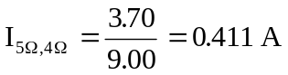
I_{5Ω} = I_{4Ω} = 0.411 A
V_{5Ω} = 0.411 × 5.00 = 2.06 V
V_{4Ω} = 0.411 × 4.00 = 1.64 V

